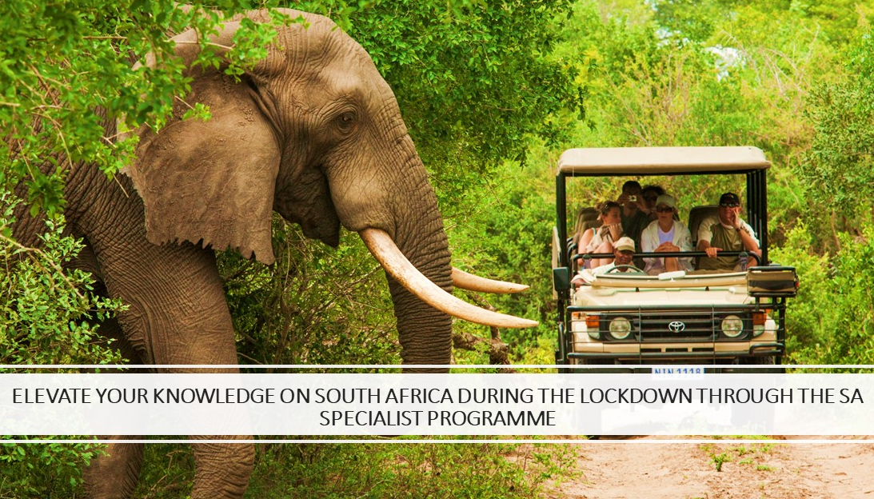
Utilize the lockdown period to elevate your knowledge on destination South Africa via the SA Specialist Programme

What is the SA Specialist programme?
SA Specialist is South African Tourism’s fun and interactive online learning programme that will help improve your knowledge of South Africa and equip you with the skills to better sell South Africa as a tourist destination.

This provides you with a unique opportunity as our valued trade partner during the lockdown period to upskill and and increase your knowledge on South Africa through South Africa Specialist on line programme. Being one of the most sought-after outbound destination by the Turkish traveller this programme will you to ensure the destination leads the consideration pack for future travel plans to our beautiful Country South Africa. .

Sign up here: https://saspecialist.southafrica.net/in/en
The course consists of two parts:
A. SA Specialist: Essentials
B. SA Specialist: Experiences

What do you get out of this?

- Improve the level of service you give clients
- Improve your marketability and branding
- Improve your earning potential
- Increase business opportunities
- Turn knowledge into wealth
- It’s free free free!

On completion you will receive
Two certificates confirming that you have completed the SA Specialist: Essentials course and the SA Specialist: Experiences course

What are the benefits?

- Be able to use the name “SA Specialist” and market yourself as a specialist on South Africa.
- As a qualified SA Specialist you would be amongst the elite travel trade partners that would have the confidence of your clients intending to travel to South Africa.
- As SA Specialist South African Tourism will consider you first when we are having fam trips therefore giving you an added advantage to be hosted on our Fam trips in the future post the lockdown.

Fun facts on SA Specialist

- March 2020 recorded the highest number of Essential Graduates from the programme in 9 years

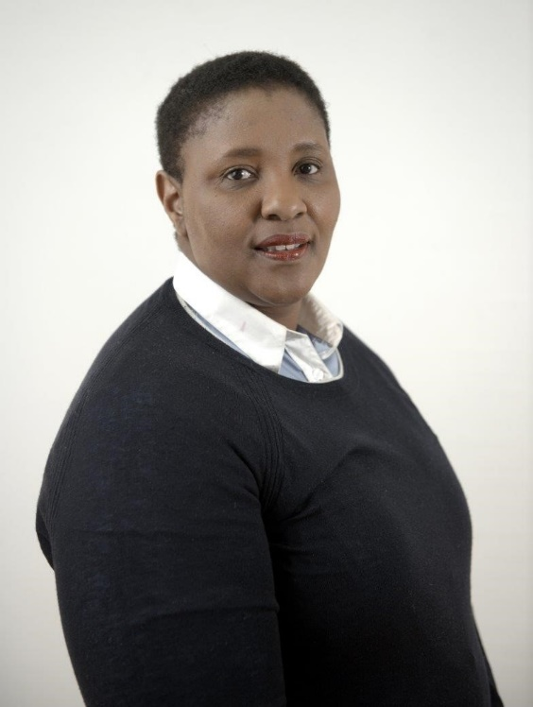
Message from the Hub Head of South African Tourism (MEISEA): Ms. Neliswa Nkani

“We are proud that the travel fraternity as always has shown resilience and is taking proactive steps to turn a global crisis into a learning opportunity by educating and upskilling themselves. It gives me great pleasure to share that March 2020 recorded the highest number of essential graduates from the programme in 9 years.

We are certain that the hunger for learning, creativity and enthusiasm fostered by the Middle East travel fraternity will go a long way in ensuring a positive turn for both, international and domestic travel sectors once the global situation stabilizes. I urge the industry to log in and sign up for SA Specialist to upskill and improve your knowledge on the destination. We extend our complete support to all our trade partners and continue to stand in solidarity with the industry during these testing times.”

